Cp_des.dbf

Cp_pri.dbf

Ec_Det.dbf

Ec_obl.dbf

ec_pri.dbf

Ejemplo:

2016004766

2016 Anual

SELECT * FROM EC_PRI WHERE COD_ALU='2016004766'

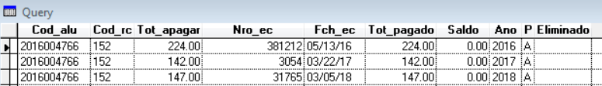

SELECT * FROM EC_OBL WHERE COD_ALU='2016004766'

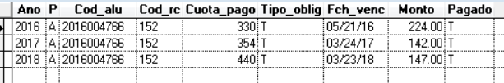

SELECT * FROM EC_DET WHERE COD_ALU='2016004766'

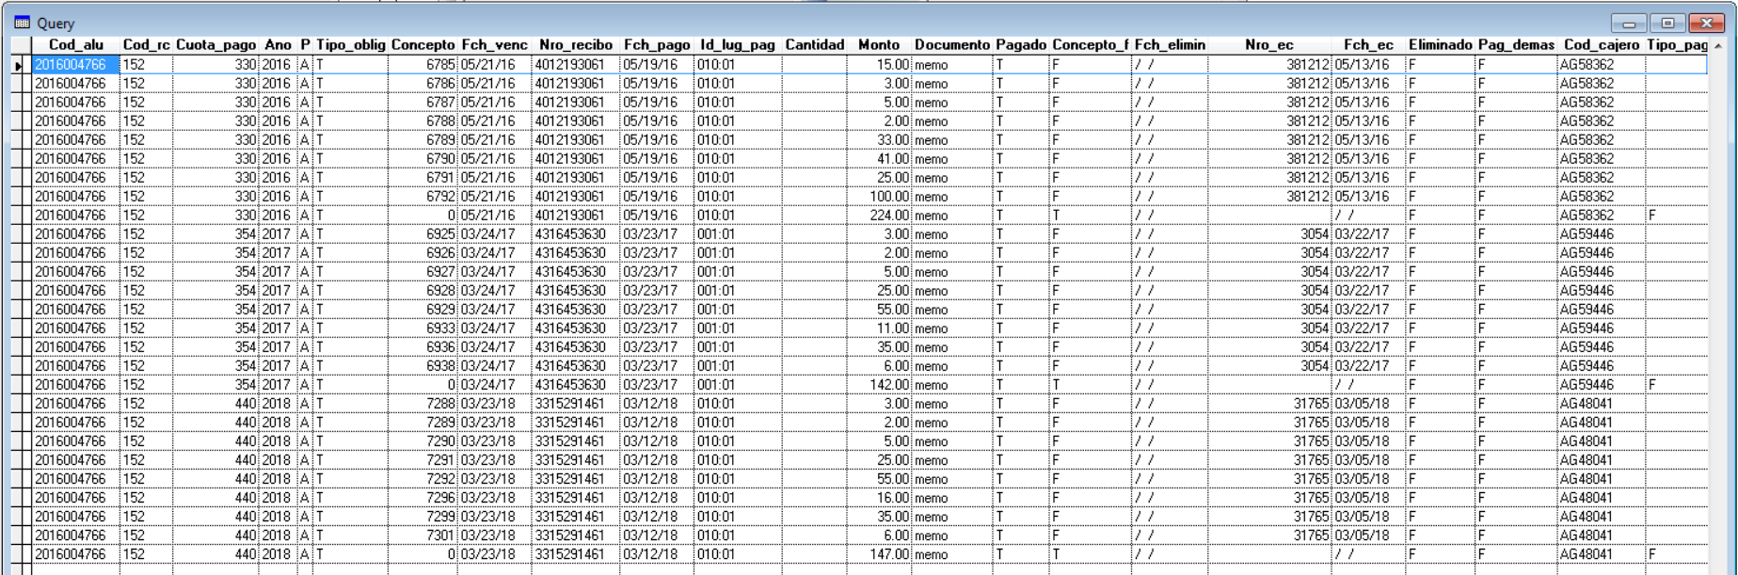

SELECT * FROM CP_PRI WHERE ID_CP=6792



SELECT * FROM CP_DES WHERE CUOTA_PAGO=330

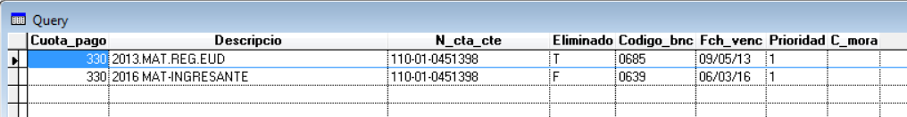

Cp_des.dbf

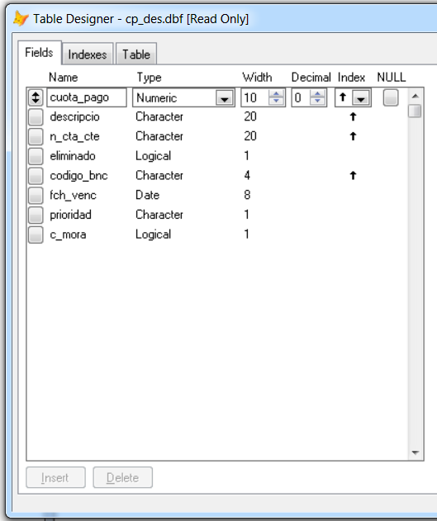

Cp_pri.dbf

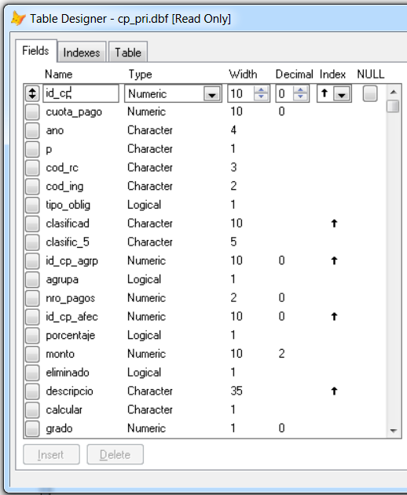

Ec_Det

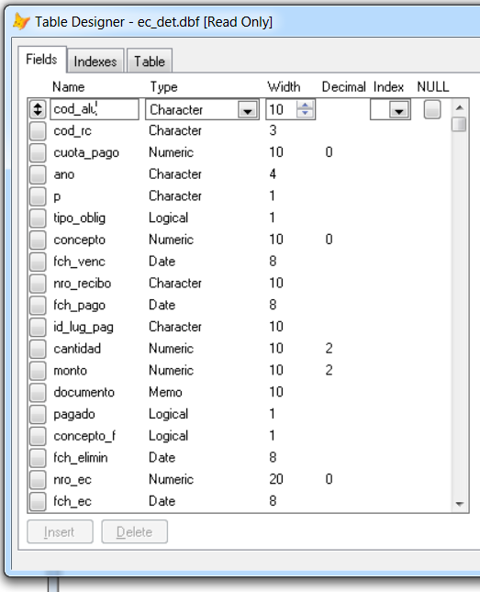

Ec_obl.dbf

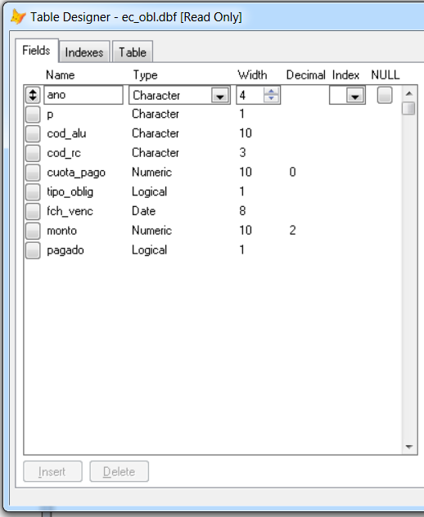

ec_pri.dbf

